Kol Simcha Torah Gazette
For parshas nasso 5786
Vol 10 Issue 33 (Whole #498) 14 Iyar 5786/ May 30, 2026
Printed L’illuy nishmas Nechama bas R’ Noach, a”h
For a free subscription, please forward your request to keren18@juno.com
Past emails can be found on the website ShabbosStories.com under Brooklyn Torah Gazette

King Charles Pledges Immediate Action Against Rising Antisemitism in Britain



King Charles III declared Wednesday that the British government would move quickly to confront antisemitism, as Jewish communities across the United Kingdom continue to face a surge in attacks, threats, and acts of violence.
Speaking during the ceremonial opening of Parliament, the King announced, “My government will take urgent action to tackle antisemitism and ensure all communities feel safe.”
Jewish leaders in Britain welcomed the statement, calling it an acknowledgment of the worsening security situation facing the country’s Jewish population.
Adrian Cohen, Acting President of the Board of Deputies of British Jews, said in a statement, “We welcome the government’s expression of commitment to take steps to tackle antisemitism included in the King’s speech, which reflects the ongoing seriousness and urgency of the situation.”
Cohen also praised the government’s plans to strengthen legislation targeting hostile foreign actors and organizations linked to terrorism.
“We also welcome the confirmation that the government will introduce legislation to tackle the growing threat from foreign state entities and their proxies, in line with recommendations made by the Independent Reviewer of State Threats Legislation Jonathan Hall KC. We call on the government to enact these powers without further delay and use them as quickly as possible to proscribe Iranian-backed threats including the IRGC,” added Cohen.
He further stated, “We outlined other key priorities to tackle threats to our community in our recent joint document Protect, Prosecute, and Partner, and will continue to push for swift and decisive government action on all these priorities, including through legislation where needed.”
The King’s remarks came as antisemitic incidents continue climbing sharply throughout Britain, especially in London. Among the recent attacks was the stabbing of two Jewish men in the heavily Jewish neighborhood of Golders Green two weeks ago.
Following that assault, British authorities elevated the national terrorism threat level from “substantial” to “severe” for the first time in more than four years.
Police last week announced the arrest of a ninth suspect connected to a major arson attack targeting Jewish community ambulances in northwest London.
The investigation focuses on a March 23 incident in Golders Green in which four emergency vehicles operated by the Hatzolah volunteer medical organization were deliberately torched.
Counterterrorism investigators are also probing attempted arson attacks directed at two synagogues in North London, along with a Jewish-owned business.
In a separate case, authorities recently arrested a 19-year-old man in Portsmouth in connection with an attempted firebombing at Finchley Reform Synagogue. He was later released on bail pending further proceedings in July.
Last Thursday, police in London arrested another suspect accused of shouting antisemitic abuse and violent threats at Jewish passengers aboard a city bus, according to the Shomrim security organization.
Earlier this week, a 34-year-old man admitted in court to carrying out multiple violent attacks motivated by hatred against Jews in North London. The defendant, who lives in Hornchurch in East London, pleaded guilty Monday before Highbury Corner Magistrates’ Court to three separate religiously aggravated offenses.
A report issued last month by Israel’s Diaspora Affairs and Combating Antisemitism Ministry found that the United Kingdom recorded the highest per-capita rate of physical antisemitic assaults among countries with major Jewish populations in 2025, documenting 121 violent incidents.
Separate figures published this year by the Community Security Trust watchdog group showed that antisemitic incidents across Britain reached 3,700 cases in 2025, marking a slight increase from the previous year and the second-highest annual total ever recorded by the organization.

Reprinted from the May 14th website of matzav.com
The Lesson of the Torah’s Repetition of the 12 Similar
Gifts of the Tribal Leaders
From the Teachings of the Lubavitcher Rebbe
Rabbi Menachem Mendel Schneerson, Zt”l


This week's Torah portion, Nasso, describes the offerings that the twelve tribal leaders of Israel brought for the altar beginning on the day the Tabernacle was consecrated. On each tribe's appointed day, its leader brought a gift.
The Torah, normally sparing in its use of words, enumerates every detail of each tribe's offering, even though all the gifts were exactly the same.
The Torah is not a history book, recording events that occurred long ago. Its teachings are relevant to each person in every generation. What, then, can we learn from the repetition of the exact same offerings twelve times?
There are twelve different paths by which a Jew can become closer to G-d, corresponding to the twelve tribes of Israel. Each tribe followed a unique path in its service of G-d. Each leader dedicated the offerings according to his own manner of spiritual service.
Despite the uniqueness of each offering, and the spiritual path which each represented, they were considered to be communal offerings. They were brought, not on behalf of the individual, but on behalf of all the Jewish people. It is for this reason, explains the Midrash, that the Torah does not distinguish whose offering was brought on which day.
This juxtaposition of the uniqueness of the individual and the equality of the collective whole is mirrored in the fact that the tribal leaders' spiritual intentions were unique while the actual physical offerings were the same. This is also true of the Jewish people; each Jew is unique and yet all Jews are equal.
There are certain qualities which all Jews share equally. And, there are also other qualities within each Jew which are uniquely personal. However, even the uniquely personal qualities can lead to unity among the Jewish people.
How so? When Jews realize that all Jews need each other, and that only by binding ourselves with our fellow Jew can we be complete.
The dedication gifts from the tribal leaders, mentioned above, were offered in a similar manner. Each leader brought his tribe's gift in a unique way on a separate day. However, each of these offerings was imbued with, and accompanied by, the feeling that this offering was also a communal offering-united with all the other leaders and tribes.

Reprinted from the Parshat Nasso 5763/2003 (Issue #773) email of L’Chaim, a publication of the Lubavitch Youth Organization in Brooklyn, NY. Excerpted from the book – “The Wellsprings of Chassidus”

Rav Avigdor Miller on the
Full Time Jobs of Mother
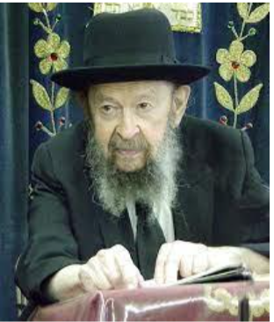

QUESTION: Why shouldn’t a mother be able to learn Gemara?
ANSWER: Gemara takes up a big part of your spare time, and women can’t afford to give all that time, because women work all day long. A man’s work is from sunrise to sunset usually, or from nine to five, but a woman’s work is around the clock; they have to raise families and they can’t afford to sit at the Gemara – otherwise, what would happen to the family?
And therefore, whenever they get a chance, when they get a little crack in their schedule, they can get in something if they wish; there are plenty of good things to learn. But Gemara, anybody who knows anything about Gemara knows that it takes up a great deal of your time.
And therefore, Hakadosh Baruch Hu says to the women: “You will get reward in the Next World for having beautiful children with good derech eretz, and frum, and also as many as you can have.” And Hakadosh Baruch Hu will reward you; you will be a millionaire in the next world. Your husband is going to be jealous of you.
It says גְּדוֹלָה הַבְטָחָה שֶׁהִבְטִיחוֹ הַקָּדוֹשׁ בָּרוּךְ הוּא לְנָשִׁים יוֹתֵר מִן הָאֲנָשִׁים – How much greater is the promise that Hashem gave to women, even more than to men (Brachos 17a). He promises it to them more easily; they go to Gan Eden more readily than men. Of course, you have the difficulties of raising your family in a kosher way, but it’s not the problem of a man. Men have various kinds of problems; they fight sometimes over kavod – glory, who is a bigger lamdan. Oh yes! Competition in business, competition in the beis hakneses. Each one wants to be elected president and gabbai; all kinds of things happen among men. But the women are excused from that kind of competitive life.
It’s not so easy to be a man; it comes with a lot of baggage. Like I always say, the only reason we make the bracha of shelo asani isha, is because a man has pockets in his suit; women don’t have pockets. It’s such a blessing to have pockets! So, when you have pockets, that’s why you can say shelo asani isha – “Baruch Hashem, I have pockets!”

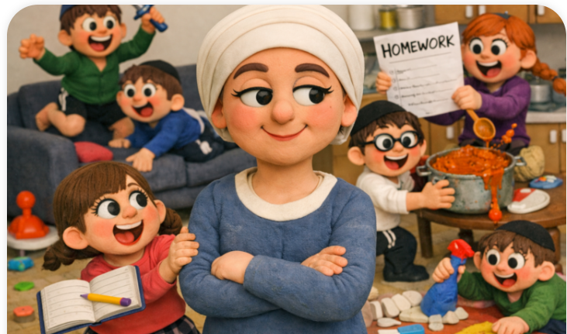

But women, mothers, can more readily have a contentment-filled ride through existence and be even more successful than men. That’s גְּדוֹלָה הַבְטָחָה שֶׁהִבְטִיחָן הַקָּדוֹשׁ בָּרוּךְ הוּא לְנָשִׁים יוֹתֵר מִן הָאֲנָשִׁים – How much greater is the promise that Hashem gave to women, even more than to men. She’ll be a very happy woman in Gan Eden.

Reprinted from the current website of Toras Avigdor. The question was asked at Rav Avigdor Miller’s Thursday night lecture back in January 1994.

What Makes You Proud?
By Rabbi Joey Haber

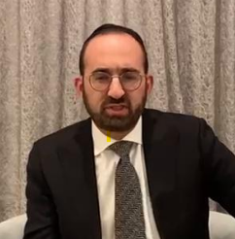

Growing up in Deal [NJ], my father was a Rabbi and my mother was a teacher. We did not have lots of money for extras like most others in the community. But not only did we not feel that we lacked anything, but to the contrary – we felt a special sense of pride. We felt proud to be a family of Torah, a family of Torah leadership and education, a family of hesed, a family that contributed so much to the community. The gap in materialism between us and others was not a factor at all. We were proud to be a family of Torah and hesed.
Sadly, many people spend lots of money that they don't have, or put themselves under a great deal of pressure to afford certain things, because they're worried about their reputation, about how people will talk about them. This is unfortunate – and wrong – for several reasons. One of which is that people who will talk negatively about somebody who hosts simple affairs, who drives a simple car, or who lives in a simple house, will likely talk negatively about him no matter what he does. It is delusional to think that we can make sure everyone thinks highly of us. I know as a Rabbi that I cannot possibly expect to win everyone's respect and admiration. There will always be people who look down on us or who criticize us, for whatever reasons.
But additionally, it is a terrible mistake to make material things our source of pride, what we're all about, the thing that our lives revolve around, as our "brand" and "label." Seeking fulfillment and happiness through material things is like eating pretzels when you're thirsty – rather than quenching the thirst, it makes you even thirstier. True joy and contentment are achieved when we live with meaning and purpose, when we fill our lives with things that really matter, that have real value. Of course there is nothing wrong with enjoying material blessings. The problem becomes when we turn materialism into the primary focus of our lives, into our primary goal, into our source of pride and of our sense of accomplishment. This will leave us feeling empty and unfulfilled.
True fulfillment comes from making our lives primarily about Torah, spirituality, hesed, contributing to the community, helping people. This is where we should be seeking our feelings of pride and gratification, and our sense of accomplishment.
להזהיר הגדולים על הקטנים. Our responsibility to our children is to fill them with pride over our identity as a Torah family, as a hesed family, as an idealistic family, as a family that lives each day the way Hashem expects His special nation to live

Reprinted from the Parshat Emor 5786 email of Rabbi David Bibi’s Shabat Shalom from Cyberspace.

Thoughts that Count
for Our Parsha

The four wagons and the eight oxen he gave to the sons of Merori (Num. 7:8).
The four wagons were needed to transport 48 fifteen-foot panels, in addition to pillars, connecting rods, ropes and pegs. Why were so few wagons provided? If it was possible to carry out the job with four wagons, it was important to do so, thereby using each one to its fullest capacity. If another wagon had been provided, the others would only have completed part of their appointed task. "G-d did not create one extra thing in His world." This applies also to our abilities and strengths. We must give our all in everything we do. (The Lubavitcher Rebbe)

And they shall confess their sin which they have committed (Num. 5:7)
Why is the commandment to confess one's sin, the first step and foundation on the path to repentance, mentioned here, where the Torah speaks about robbery? Because any sin a person may commit has an element of robbery in it. G-d gives a person life and strength, in order that he use these gifts to perform His will. If one takes these precious gifts and uses them to defy G-d's commands, he is misusing and "stealing" the property of his Creator. (Chidushei HaRim)

And he shall atone for him, because he sinned against the soul (Num. 6:11)
The Rebbe of Sadigora used to say: Just as in the World-to-Come a Jew will have to account for how he neglected his soul and how he caused it pain, so will he have to defend himself to G-d for having brought pain and suffering to his body.

The L-rd bless you and keep you (Num. 6:24)
The Priestly blessing is said in the singular because it is mainly the blessing of unity that the Jews need. (O'lot Efraim)

Reprinted from the Parshat Nasso 5763/2003 (Issue #773) email of L’Chaim, a publication of the Lubavitch Youth Organization in Brooklyn, NY.

Jerusalem: From Biblical Desolation to Over 1 Million People
By Nissan Ratzlav-Katz

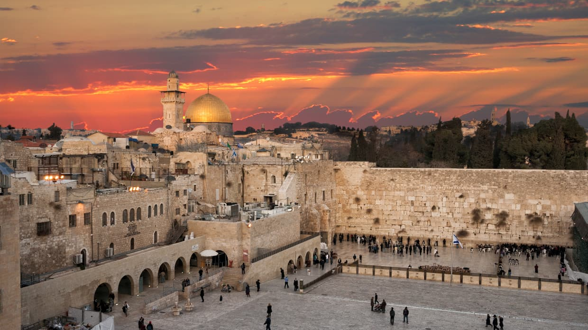
For centuries, Jerusalem was a ghost town. Today it's a city of 1 million, one of the fastest-growing travel destinations on earth. How did this happen?

“What shall I tell you regarding the Land? It is very neglected and desolate... The more sacred the place, the greater its desolation. Jerusalem is the most desolate of all...”
So wrote Rabbi Moshe ben Nachman (Ramban or Nachmanides), one of the towering rabbinical figures of the Middle Ages, in a letter to his son in 1267. Already an elderly man at that point, he arrived in the Land of Israel after fleeing persecution in Spain. The Jerusalem he saw had been devastated by the competing conquests of Crusaders, Mongols and Mamluks.
A very different chronicler arrived in the city around 1491. Martin Kabátník, a member of the Bohemian Christian sect known as the Unity of the Brethren, wrote in his Journey to Jerusalem:
“There are few Christians but there are many Jews, and these the Muslims persecute in various ways. Christians and Jews go about in Jerusalem in clothes considered fit only for wandering beggars. The Muslims know that the Jews think and even say that this is the Holy Land which has been promised to them and that those Jews who dwell there are regarded as holy by Jews elsewhere, because in spite of all the troubles and sorrows inflicted on them by the Muslims, they refuse to leave.”
Nearly 115 years later, a highly influential work titled A Relation of a Journey begun An. Dom. 1610, by George Sandys, was published in London. The book describes Jerusalem as “buried in her own ruins....”
Dutch Orientalist, professor and theologian Adrian Reland wrote in a two-volume work, Palaestina ex monumentis veteribus illustrata (published 1714), that Jerusalem at the start of the 18th century was home to around 5,000 people. Most of them, he noted, were Jews.
A more descriptive and chilling account was provided by the famous French writer and diplomat François-René de Chateaubriand less than 100 years later, in Itinéraire de Paris à Jérusalem et de Jérusalem à Paris (published 1811). Describing the Jews of Jerusalem circa 1806, he wrote:
“One must see these people in Jerusalem; one must see these rightful masters of Judea living as slaves and strangers in their own inheritance; one must see them awaiting, under every form of oppression, a king who is to deliver them.... Crushed by the Cross and the Crescent, they still wander about, seeking for their country and finding only a grave.”
An author later known for a very different reason, Karl Marx, published an article that appeared in the New-York Daily Tribune on April 15, 1854, describing Jerusalem at the time. He noted that the city had a population of about 15,500 people, of whom 8,000 were Jews.
“The Mussulmans,” Marx wrote, “forming about a fourth part of the whole, and consisting of Turks, Arabs and Moors, are, of course, the masters in every respect, as they are in no way affected with the weakness of their Government at Constantinople. Nothing equals the misery and the sufferings of the Jews at Jerusalem, inhabiting the most-filthy quarter of the town, called hareth-el-yahoud, the quarter of dirt [sic], between the Zion and the Moriah, where their synagogues are situated the constant objects of Mussulman oppression and intolerance, insulted by the Greeks, persecuted by the Latins, and living only upon the scanty alms transmitted by their European brethren.”
Another famous author, Herman Melville of Moby-Dick fame, visited Jerusalem around 1857. In a private journal, he described the city as a “collection of abandoned stone quarries.” As he put it, “No country will more quickly sicken the fancy than the face of Judea.... The yard-walls look like old tomb-stones... Jerusalem is a city of stones.”
A little over a decade later, Mark Twain wrote in The Innocents Abroad (published in 1869) that “Jerusalem is mournful, and dreary, and lifeless. I would not desire to live here.”
Jeremiah mourned the destruction of Jerusalem and also provided a bright vision of the city’s future.
Echoing Ramban from nearly 630 years earlier, the famous French novelist and naval officer Pierre Loti wrote in 1894, “Jerusalem, the city of sadness... I have seen the desolation of many ruins in the world, but none so heavy as this. It is a city that has died of its own holiness.”

If I Forget Thee, O Jerusalem
Jeremiah (Yirmiyahu), who lived between 627 and 587 BCE, saw and mourned the destruction of Jerusalem in his day. He described “the towns of Judah and the streets of Jerusalem” as being “desolate, without inhabitant, human or animal…” (33:10-11)
However, in the same passage he also provided a bright vision of the city’s future, in which “there shall once more be heard the voice of mirth and the voice of gladness, the voice of the bridegroom and the voice of the bride, the voices of those who sing, as they bring thanks offerings to the house of the Lord: ‘Give thanks to the Lord of hosts, for the Lord is good, for his steadfast love endures forever!’ For I will restore the fortunes of the land as at first, says the Lord.”
It was long in coming, but the vision began to take shape in 1949. Shortly after Israel’s War of Independence, Prime Minister David Ben-Gurion rejected United Nations efforts to internationalize the city and instead declared Jerusalem to be “an inseparable part of the state of Israel and its eternal capital.”
Yet for the next 19 years, the city remained divided between the Jewish state and the Hashemite Kingdom of Jordan.
Then, on June 5, 1967, Israeli Prime Minister Levi Eshkol sent an urgent message to King Hussein saying that “we shall not engage ourselves in any action against Jordan, unless Jordan attacks us.” The king ignored Israel’s appeal and joined neighboring Arab states in their attempt to destroy Israel.
On the 6th of June, the 27th of Iyar in the Jewish calendar, the first Israeli national unity government since 1948 held its initial Ministerial Security Committee meeting. On the agenda was the response to Jordan and the liberation of Jerusalem. In accordance with the decision taken, IDF forces encircled the Old City that very day.
The modern holiday of Yom Yerushalayim (Jerusalem Day) takes place one day later – this year, it starts on Thursday night, the 14th of May – marking the city’s full liberation from Jordan during the Six-Day War.
But none of it might ever have happened had Jordan opted for peace or even hesitated a few days. The rest, as they say, is history.

A Hub of Life, Learning, and Love
Since 1967, the unified capital of Israel has more than tripled in population size to become the nation’s largest city. And in 2024, Jerusalem became the first Israeli city to have more than 1 million residents (1,046,300 by May 2025).
Part of that increase is due to new immigrants (olim). Jerusalem is the number one destination for olim, with about 3,000 of them moving to the city every year. According to Pini Glinkevitch, director of the city’s Immigration and Absorption Authority, the largest contingent is from South America, followed by the United Kingdom and the United States.
The world of Torah learning and academia are also flourishing in the capital.
There are more than 500 yeshivas and kollels (advanced study halls for married men) within the Jerusalem municipal boundaries alone. For comparison, there were only approximately 200 major yeshivas across Eastern Europe on the eve of World War II. The largest single yeshiva at the time was the Mir Yeshiva in Belarus, which had about 500 students. The reconstituted and replanted Mir Yeshiva in Jerusalem has around 9,000 students today.
The Hebrew University of Jerusalem is recognized as one of the world’s elite academic institutions, with international ranking higher than Harvard and Oxford in some subjects. This single university has produced 10 Nobel Laureates, one Fields Medal winner, two Turing Award winners, and its technology transfer company, Yissum, is ranked 15th in the world with over 10,000 registered patents.
No wonder the Startup Genome report has been consistently ranking Jerusalem (and Tel Aviv) as among the most vibrant tech hubs in the world in recent years.
In tourism, as well, Jerusalem is no longer “mournful, and dreary, and lifeless,” per Mark Twain. In 2019, the UK-based market research company Euromonitor International declared Jerusalem to be “the fastest-growing travel destination in the world…” out of 600 cities worldwide and “a top global tourism spot.”
On the cultural front, Jerusalem is home to world-class institutions like the Israel Museum (housing the Dead Sea Scrolls and an incredible collection of fine arts and archaeology), Yad Vashem, the Bible Lands Museum, the Tower of David museum and exhibit in the Old City, and the Bezalel Academy of Arts and Design (one of the world's most prestigious art schools). In addition, specific events like the Jerusalem Light Festival and the prestigious International Book Forum regularly draw tens and sometimes hundreds of thousands of visitors from around the world.
Time Magazine included Jerusalem in its 2023 list of the 50 “World's Greatest Places.” Based on nominations by the magazine’s international network of correspondents and contributors, the city was especially highlighted for its culinary scene and “modern-meets-ancient” vibes.
And to connect all the dots, let’s note that “the sound of mirth and gladness, the voice of bridegroom and bride” is heard at about 19,000 weddings every year in Jerusalem alone.

Not Just for the Jews
Despite all the libelous claims to the contrary, Israeli control over Jerusalem has been a continuing boon for its non-Jewish residents as well.
From 1910 until 1946, the non-Jewish population of Jerusalem went from 24,900 to 65,100. That's a total net growth of 40,200 in 35 years, or 161 percent. Not bad at all for a city under British colonial occupation.
Then, in 1948, Jerusalem came under Jordanian occupation – and non-Jewish population growth went down to near-zero. And there was, of course, no Jewish population growth whatsoever since there were no Jews left after Jordan’s thorough ethnic cleansing of the city.
When Jerusalem came under exclusive Israeli sovereignty in 1967, the situation changed dramatically. From 1967-2025 the non-Jewish population of Jerusalem grew from 68,600 people to roughly 400,000 (around 40% of the city).
“Next Year in Jerusalem” is Now
Jewish people have been saying “Next year in Jerusalem” at the end of every Passover Seder, smashing a glass to remember Jerusalem at every wedding, mentioning Jerusalem at every meal, and turning to face Jerusalem for every prayer for nearly 2,000 years, wherever they were in the Diaspora. It is this living memory that helped make the vision of Jeremiah a reality and the reborn capital of the Jewish state a blessing for its residents and for the world.
Happy Jerusalem Day!

Reprinted from the current website of aish.com

Mordechai Sheftall: Patriotic Officer, Prisoner of War,
and Proud Jew
By Yaakov Landman

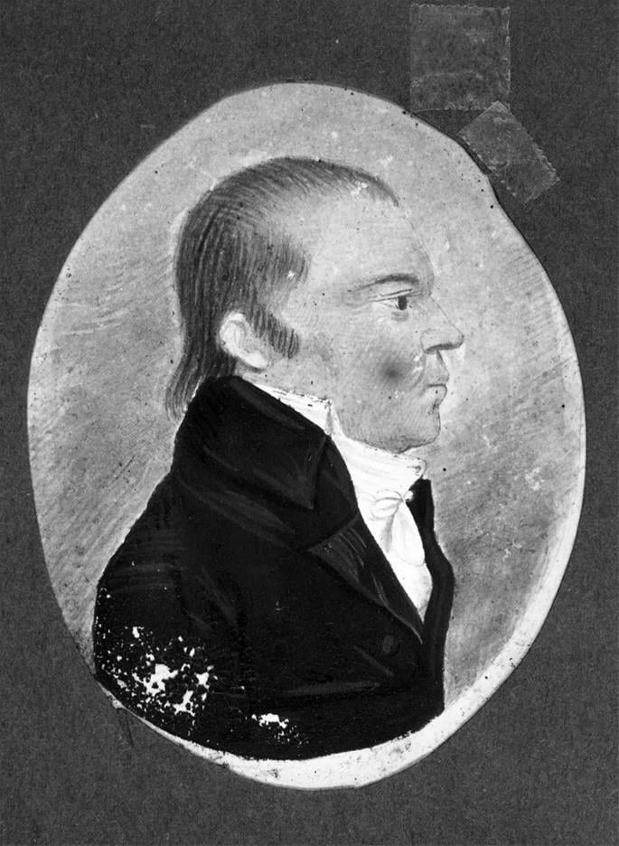
Mordechai Sheftall

Mordechai Sheftall, 1735-1797, the highest-ranking Jew to serve in the American Revolution, was a devout Jew who stood strong in his beliefs and a fiercely patriotic American who suffered for his country.
His parents, Benjamin and Perla Sheftall, originally from Germany, were among the first group of Jewish settlers to Savannah, Georgia, and for many years Benjamin kept a diary recounting the goings on of the fledgling community. In December 1735 they were blessed with a son, Mordechai. Tragically, Perla passed away when Mordechai was still an infant, and his father married Chana Solomons three years later.
Many members of the community were former conversos who had escaped Portugal and returned to Judaism. Their sense of safety was shattered when Britain and Spain went to war in 1739 in the War of Jenkins’ Ear, which brought the fighting dangerously close to home.
Spain had long claimed Georgia as its own territory and disputed the British right to settle there, and the Spanish governor of Florida led an invasion into Georgia. Thankfully, Georgia remained in British hands, but fear that a successful conquest would bring the Inquisition to their new home led almost the entire Jewish community of Savannah to disperse.
The Sheftalls, however, stayed on, possibly the only Jewish family in the colony of Georgia for many years. Nevertheless, Benjamin remained a committed Jew and raised his family accordingly. Written records even show his frustration when the tefillin he ordered from London for Mordechai’s bar mitzvah did not arrive in time!
Branching Out
As an adult, Mordechai turned to business to secure his future. To start, he bought deerskins, which he tanned and sold. Eventually, he did well enough to buy land. He also received land grants from the colony in order to develop them.
His business dealings brought him in contact with Joshua Hart in Charleston, South Carolina, who thought Mordechai would be a wonderful match for his sister Fanny. The couple married in October 1761.
They had six children together: Sheftall, born 1762 (yes, his name was actually Sheftall Sheftall!); Perla (named for Mordechai’s mother), born 1763; Elias, born 1765, who died shortly after birth; Benjamin (named for Mordechai’s father who had passed away two years earlier); Moses, born in 1769; and Esther, born 1773.
Mordechai continued his father’s trajectory, raising his family to be committed, observant Jews. To his good fortune, throughout the years of raising his children, Jews began to return once again to Savannah, and by 1774 there were enough Jews to form a minyan for the High Holidays, which was held at the Sheftall home.
The Sheftall home now became a functioning synagogue, with services held every Shabbat and holiday. Until, that is, the outbreak of the American Revolution.

Fierce Patriot
When the Revolutionary War broke out, Mordechai was a wealthy and distinguished citizen of Savannah. He quickly became a fierce Patriot, head of the “parochial committee,” which enforced the Continental Congress’s ban on British commercial goods entering the colony. Mordechai turned away any British commercial vessel seeking to dock at Savannah.
He did such a good job that in 1778 he was appointed Commissary General to the Continental troops in Georgia, becoming the highest-ranking Jew to serve in the American Revolution.
But before Congress could officially certify his position, Mordechai became a POW.

Captured by the British
Incredibly, we have a letter written by Mordechai himself where he details the story of his capture:
“This day [December 29, 1778] the British troops, consisting of about 3,500 men, including two battalions of Hessians under the command of Lieutenant Colonel Archibald Campbell of the Seventy-first Regiment of Highlanders, landed early in the morning at Brewton Hill, two miles below the town of Savannah, where they met with very little opposition before they gained the height.
At about three o'clock p.m. they entered and took possession of the town of Savannah, when I endeavored, with my son Sheftall, to make our escape across Musgrove Creek, having first premised that an intrenchment had been thrown up there in order to cover a retreat, and upon seeing Colonel Samuel Elbert and Major John Habersham endeavor to make their escape that way.
But on our arrival at the creek, after having sustained a very heavy fire of musketry from the light infantry under the command of Sir James Baird, during the time we were crossing the Common, without any injury to either of us, we found it in high water. And my son not knowing how to swim, and we with about 186 officers and privates being caught, as it were, in a pen, and the Highlanders keeping up a constant fire on us, it was thought advisable to surrender ourselves prisoners, which we accordingly did.
And which was no sooner done than the Highlanders plundered every one amongst us, except Major Low, myself, and son, who, being foremost, had an opportunity to surrender ourselves to the British officer, namely, Lieutenant Peter Campbell, who disarmed us as we came into the yard formerly occupied by Mr.Moses Nunes.”
Later in his narrative, Mordechai describes the abuses he suffered as a Patriot prisoner of war:
On our way to the white guardhouse we met with Colonel Campbell, who inquired of the Major who he had got there. On his naming me to him, he desired that I might be well-guarded, as I was a very great rebel. The major obeyed his orders, for, on lodging me in the guardhouse, he ordered the sentry to guard me with a drawn bayonet and not to suffer me to go without the reach of it, which orders were strictly complied with until a Mr. Gild Busler, their commissary general, called for me and ordered me to go with him to my stores, that he might get some provisions for our people, who, he said, were starving, not having eat[en] anything for three days, which I contradicted, as I had victualled them that morning for the day.
In our way to the office where I used to issue the provisions, he ordered me to give him information of what stores I had in town and what I had sent out of town, and where. This I declined doing, which made him angry. He asked me if I knew that Charlestown [South Carolina] was taken. I told him: “No.” He then called us poor, deluded wretches, and said, “Good G-d! How are you deluded by your leaders!” When I inquired of him who had taken it, and when, he said, General [James] Grant, with 10,000 men, and that it had been taken eight or ten days ago, I smiled and told him it was not so, as I had a letter in my pocket that was wrote in Charlestown but three days ago by my brother.
He replied we had been misinformed. I then retorted that I found they could be misinformed by their leaders, as well as we could be deluded by ours. This made him so angry that when he returned me to the guardhouse, he ordered me to be confined amongst the drunken soldiers and negroes, where I suffered a great deal of abuse and was threatened to be run through the body or, as they termed it, “skivered” by one of the York Volunteers, which threat he attempted to put into execution three times during the night, but was prevented by one Sergeant Campbell …
After spending a few days in the guard house, Mordechai and his son Sheftall were transferred to an even worse confinement, imprisonment on the Nancy, one of the infamous British prison ships, where one of the first things Mordechai saw “was one of our poor Continental soldiers laying on the ship’s main deck in the agonies of death, and who expired in a few hours.”
But even during the harsh conditions of prison life, Mordechai remained committed to his faith. A friend of his, Reverend Moses Allen, who tragically drowned while trying to escape from the ship, wrote in his diary, which was subsequently recovered from his body: “Pork for dinner. The Jews, Sheftall and son, refused to eat their pieces, and their knives and forks were ordered to be greased with it. It is happiness that Mr. Sheftall is a fellow sufferer. He bears it with such fortitude as is an example to me.”
Through thick and thin, Mordechai stuck to his religion and his country.

Release and Recapture
Mordechai was eventually released on parole to Sunbury, around 30 miles south of Savannah, where he was kept under watchful eye by the British authorities. His son Sheftall continued to languish on the Nancy, until he too was paroled in June 1779, when he rejoined his father.
Throughout their period of internment and parole, Mordechai wrote frequently to his wife, Fanny, who had taken the children to the safety of Charleston shortly before Mordechai and his son were captured. Their letters indicate that they had a very loving relationship.
In one postscript from 1780, Fanny adds: “Perla begs that you will excuse this scrool, as she has wrote it in great haste, and our Sabbeth is coming on so fast.” Clearly, there is nothing modern to the pre Shabbat rush!
In October 1779, following threats to their lives by a local Tory militia, the Sheftall’s decided to escape from Sunbury as per the advice of the Continental Army who recommended that “they remove themselves to a place of safety, but to consider themselves still on parole.”
Mordechai, Sheftall, and several other American officers boarded a small ship with the aim of sailing to Charleston. No doubt Mordechai was eagerly looking forward to reuniting with his wife and children whom he had not seen for close to a year. Unfortunately, it was not to be, because he was captured again!
The HMS Guadalupe intercepted their ship, and Mordechai and Sheftall were once again prisoners. This time, the Guadalupe took them to the Caribbean isle of Antigua, where they remained as prisoners for several months before being released for a second time on parole. June 1780 found Mordechai and son safe and sound back behind American lines in Philadelphia.
Fanny and the kids, however, were stuck in what was now British-occupied Charleston, which had fallen to the British following a siege. (Fanny mentions in a letter to her husband that the cannonballs “flew like hail during the cannonading.”) The Sheftall family would have to wait till the end of hostilities before reuniting.
Mordechai, of course, did not sit idly by for the rest of the war. He invested in a privateering ship (which failed miserably; the ship ran aground on its first mission), and Sheftall commanded a relief ship bringing supplies to American prisoners in Charleston.
Rebuilding in Savannah
The reunited Sheftall family returned to Savannah in 1782, where Mordechai resumed his prewar business and community activities. He was actively involved in building Jewish Savannah, becoming a founding member and president of Congregation Mikve Israel, and establishing a Jewish cemetery, where his grave can be visited today.
Mordechai passed away on July 6, 1797, at 61 years old, a beloved father, husband, outstanding citizen, and pillar of the Savannah Jewish community.
Sources:
American Jewish Archives, published by the American Jewish archives 1975.
The Sheftall diaries: Vital records of Savanah Jewry 1733-1808, Malcolm H. Stern, American Jewish historical Quarter vol 54 no 3 (March 1965)
A Drowned Body, newly discovered Documents, and a Jew’s persecution during the American revolution:

Reprinted from the current website of Chabad.Org

